# **Report**

|  |  |
| --- | --- |
| Date | 28-07-2025 |
| Team ID | Yashraj Srivastava |
| Project Name | Predicting Plant Growth Stages with Environmental and Management Data Using Power BI |
| Maximum Marks | 5 Marks |

A report is a comprehensive document that provides a detailed and structured account of data analysis, findings, and insights. It is typically used for in-depth analysis, documentation, and communication of results. Reports are suitable for a diverse audience, including decision-makers, analysts, and stakeholders who need a comprehensive understanding of the data.

Designing a report in Power BI involves connecting to data sources, creating visualizations like charts and graphs, customizing their appearance and interactivity, organizing them logically on the canvas, formatting elements for consistency and clarity, and optionally creating dashboards for a summarized view. Throughout the process, it's essential to consider the audience's needs and ensure the report effectively communicates insights from the data. Finally, iterate based on feedback to continually improve the report's design and usefulness.

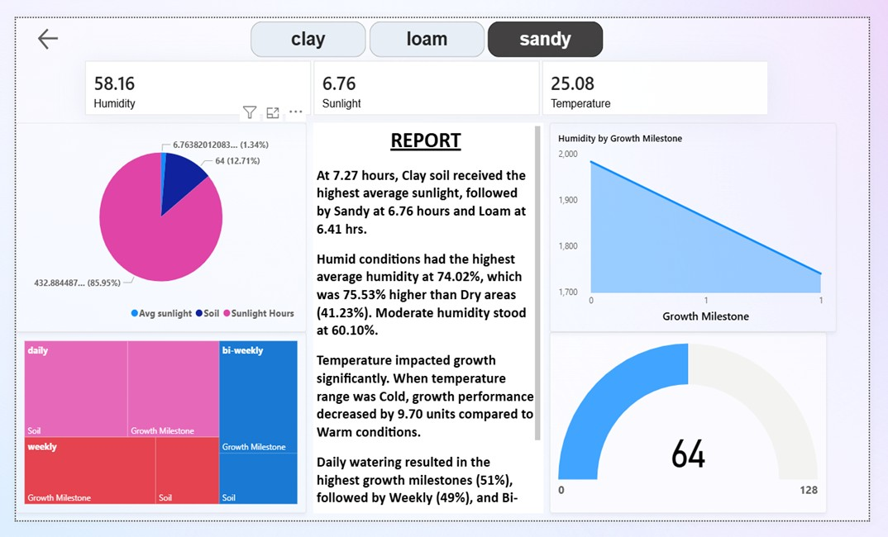

**The report provides an analysis of soil conditions and their impact on plant growth:**

1. **Sunlight Exposure:** 
   1. Clay soil received the highest average sunlight at 7.27 hours
   2. Sandy soil followed with 6.76 hours
   3. Loam soil received 6.41 hours

1. **Humidity Levels:** 
   1. Humid conditions had the highest average humidity at 74.02%
   2. This was 75.53% higher than dry areas (41.23%)
   3. Moderate humidity was recorded at 60.10%

1. **Temperature Effects:** 
   1. Temperature significantly impacted growth
   2. Cold temperature ranges decreased growth performance by 9.70 units compared to warm conditions

1. **Watering Frequency and Growth:** 
   1. Daily watering resulted in the highest growth milestones (51%)
   2. Weekly watering followed at 49%
   3. Bi-weekly watering was also mentioned but percentage not specified

1. **Additional Data:** 
   1. Current humidity: 58.16%
   2. Current sunlight: 6.76
   3. Current temperature: 25.08

The report highlights the importance of various environmental factors on plant growth, emphasizing the roles of soil type, sunlight exposure, humidity, temperature, and watering frequency.